**DIGITAL VOTING MACHINE**

**SUBMITTED BY**

**SREEJITH A (59)**

**SUJITH V I (61)**

**TAPAN MANU (63)**

**ATOZ M (20)**

**CONTENTS**

**1. Introduction**

**2. Abstract**

**3. System Requirements**

**4. Use CaseDiagram**

**5. Data flow diagram**

**6. Database Schema**

**7. Design**

**8. Module description**

**9. Conclusion**

# 

# **INTRODUCTION**

This is a java based digital voting machine which replicates the actual voting machine in a secure and efficient manner. Each user is accessed completely using their unique identity like Aadhar number. This has already been updated to the database by respected authority through admin portal. This application keeps track of every action done by the user and stores every detail in an encrypted format which can only be decrypted by required authority only after the election is over. Admins can manage the database, they can create, delete and edit everything before the election gets started. This application will provide more ease for managing the data than manual elections conducted nowadays, thus reduces time consumed and makes work easy and also efficient.

# **ABSTRACT**

An organized system is essential for complete monitoring of election procedure. We introduce an efficient, secure and user friendly application for elections. Nowadays security is more important for any type of election. Thus we mainly incorporate efficient encryption techniques and also a strong database foundation for digital voting machines. There are many authorities who feel problems managing election procedures and datasets with our project manual work gets decreased and storage is completely digitized. In general, this project aims to enhance efficiency and at the same time maintain information accurateness. Our work is useful for easy user interface. We are planning to utilize the powerful database management, data retrieval and data manipulation. We will provide more ease for managing the data than manually maintaining the documents. Our work is useful for saving valuable time and reduces the big paperwork.

# **SYSTEM REQUIREMENTS**

**Hardware System Configuration :**

| **Requirements** | **Value** |
| --- | --- |
| **Processor** | **Core i3** |
| **Speed** | **2 GHz or higher** |
| **RAM** | **256 MB or higher** |
| **Hard Disk** | **20 GB or higher** |

**Software System Configuration :**

| **Requirements** | **Value** |
| --- | --- |
| **Operating System** | **Ubuntu 18.04/Windows 7/NT/2000** |
| **System**  **Architecture** | **Intel(x86),**  **AMD64 and Intel EM64T** |
| **Developing Tool** | **JDK 11.0.9** |
| **Database** | **MYSQL 5.7** |
| **Front End** | **Java, JSP** |

**DATABASE SCHEMA**

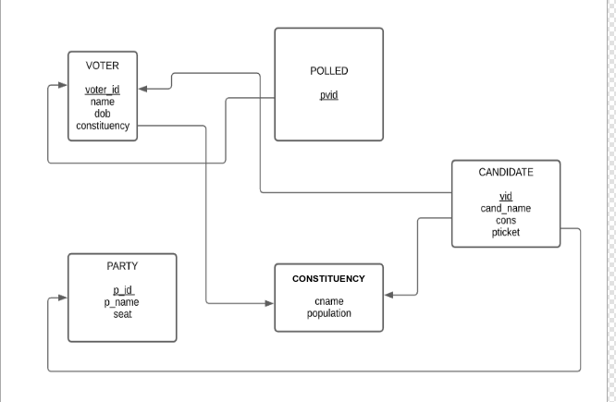

**VOTER**

| **ATTRIBUTE** | **DATATYPE** | **CONSTRAINTS** |
| --- | --- | --- |
| **VOTER_ID** | **Varchar** | **NOT NULL** |
| **NAME** | **Varchar** | **NOT NULL** |
| **DOB** | **Date** | **NOT NULL** |
| **CONSTITUENCY** | **Varchar** | **NOT NULL** |

**CANDIDATE**

| **ATTRIBUTE** | **DATATYPE** | **CONSTRAINTS** |
| --- | --- | --- |
| **V_ID** | **Varchar** | **NOT NULL** |
| **CAND_NAME** | **Varchar** | **NOT NULL** |
| **CONS** | **Varchar** | **NOT NULL** |
| **PTICKET** | **Varchar** | **NOT NULL** |

**PARTY**

| **ATTRIBUTE** | **DATATYPE** | **CONSTRAINTS** |
| --- | --- | --- |
| **P_ID** | **Number** | **NOT NULL** |
| **P_NAME** | **Varchar** | **NOT NULL** |
| **SEATS** | **Varchar** | **NOT NULL** |

**CONSTITUENCY**

| **ATTRIBUTE** | **DATATYPE** | **CONSTRAINTS** |
| --- | --- | --- |
| **CNAME** | **Varchar** | **NOT NULL** |
| **POPULATION** | **Number** | **NOT NULL** |

**POLLED**

| **ATTRIBUTE** | **DATATYPE** | **CONSTRAINTS** |
| --- | --- | --- |
| **PVID** | **Varchar** | **NOT NULL** |

# 

# 

# 

# 

# 

# 

# 

# 

# 

# **USE CASE DIAGRAM**

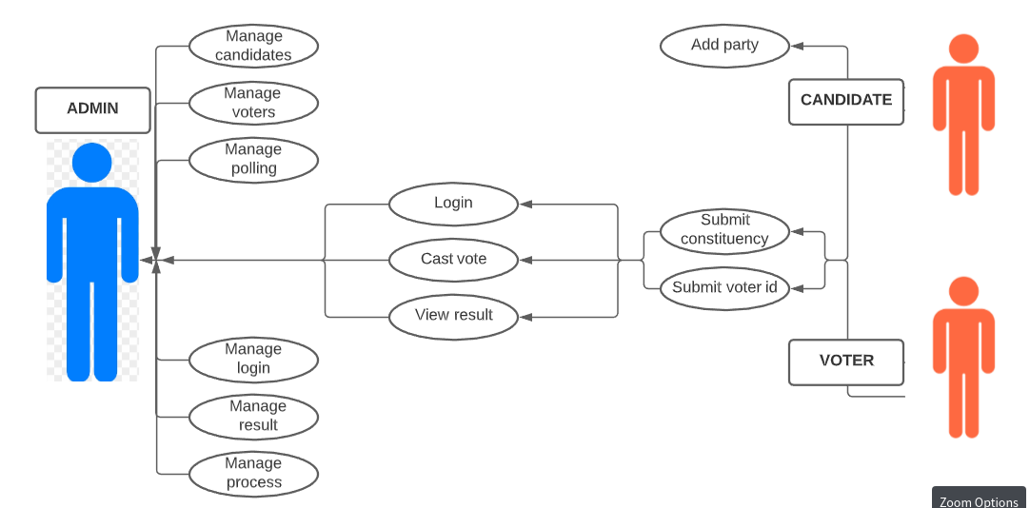

# 

# 

# 

# 

# 

# **DATAFLOW DIAGRAM**

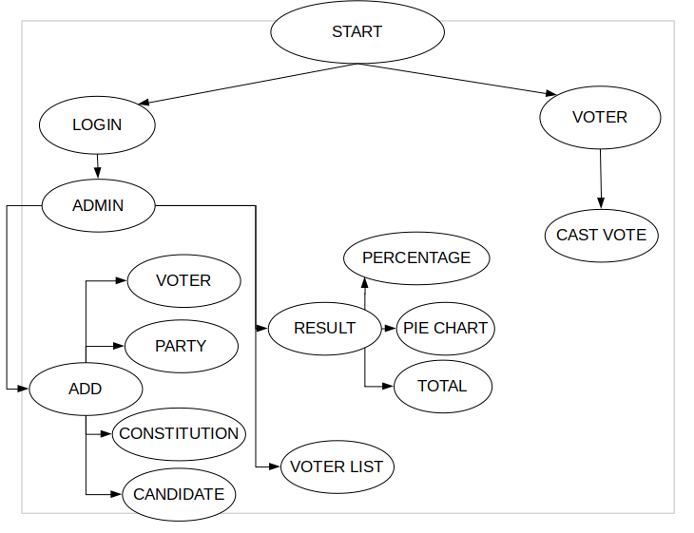

# 

# 

# **ER DIAGRAM**

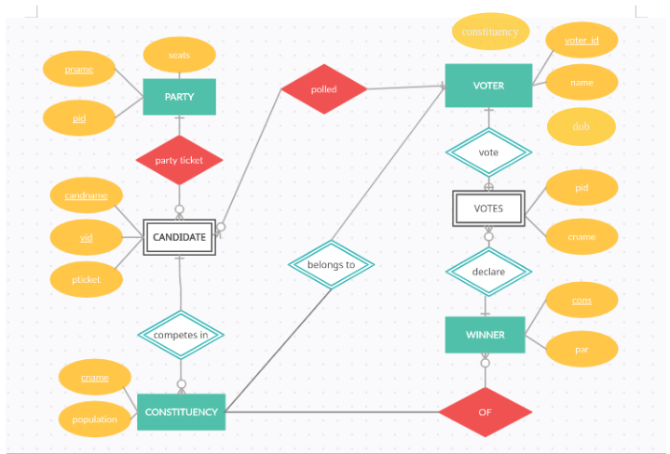

# 

# 

# 

# 

# **MODULE DESCRIPTION**

# 

# 

# **VOTER MODULE**

# In this module we store the details of a voter like name,dob,constituency, ID.

# VOTER_ID - primary key and represent unique ID for each person eligible for voting (age greater than 18).

* Name - Name of the voter
* Dob - Date of birth of voter
* Constituency - represent the constituency of voter

Age eligibility of applicant is verified and aadhar number/unique id of each person is accepted to ensure the person has a valid identity. Apart from this,

The constituency is also verified to ensure that valid constituency is being entered. The software then generates a Unique Voter ID which acts as the primary key of the voter table and then each value is inserted to the table,

Else the application gets rejected if any of the above conditions fail.

# **CANDIDATE MODULE**

# In this module we store the details of a candidate like pticket,name, ID,constitution.

* V_ID - ID for Candidate . Same key as that of Voter_ID.
* Cand_Name - Name of the candidate . Same name as that in the Voter table.
* Cons - Field that represents the constituency in which the candidate is contesting.
* Pticket - Field that represents the party in which the candidate has received a ticket for election contesting.

A combination of above all fields constitute the unique key since the feature allowed the same candidate to contest in multiple constituencies under the same party or independent. The age of the candidates (above 25) is also verified. The validity of the party is also checked.

# **3. PARTY MODULE**

# In this module we store all the information about the party of all candidates.

* PID - Unique ID for party .
* Pname - Party name
* Seats - No of seats the party has acquired during election. Initialized to 0 by default

Useful in registration phase of voter and candidate

# **4.POLLED MODULE**

# In this module we store all the information about the polled.

# The primary key P_VID which references VOTER_ID in the voter module.

# **5.CONSTITUENCY MODULE**

# In this module we store all the information about the constituency. This is for the percentage calculation and for probability calculation with respect to previous year.

# Cname - name of constituency

# Population - the population within the constituency.

**Registration Phase**

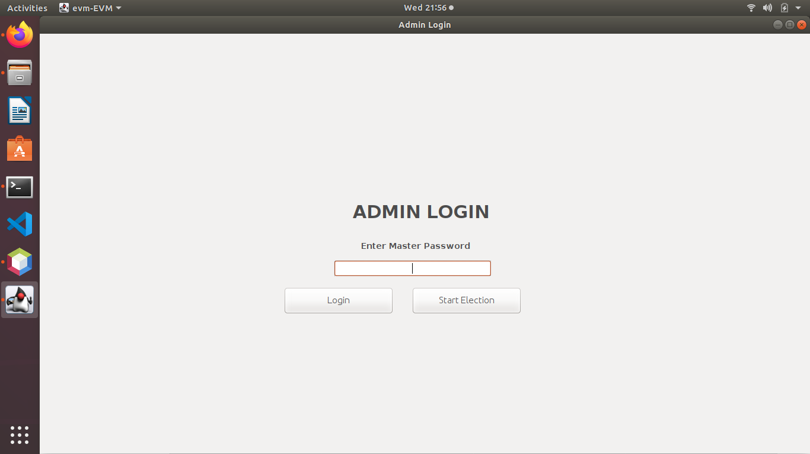

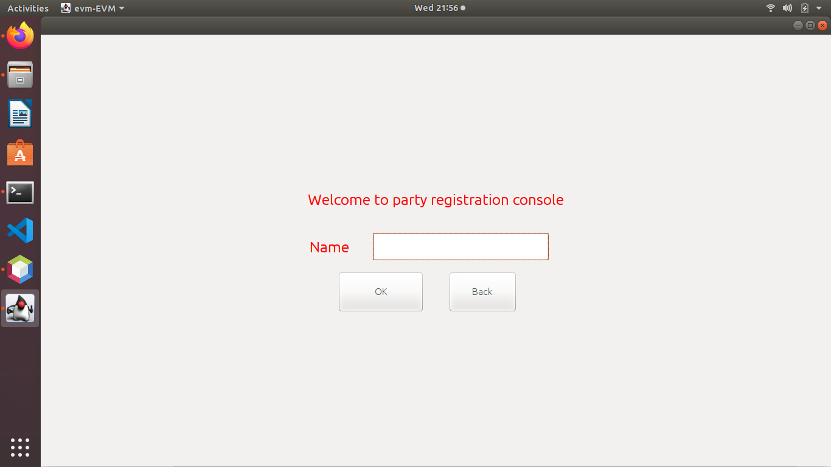

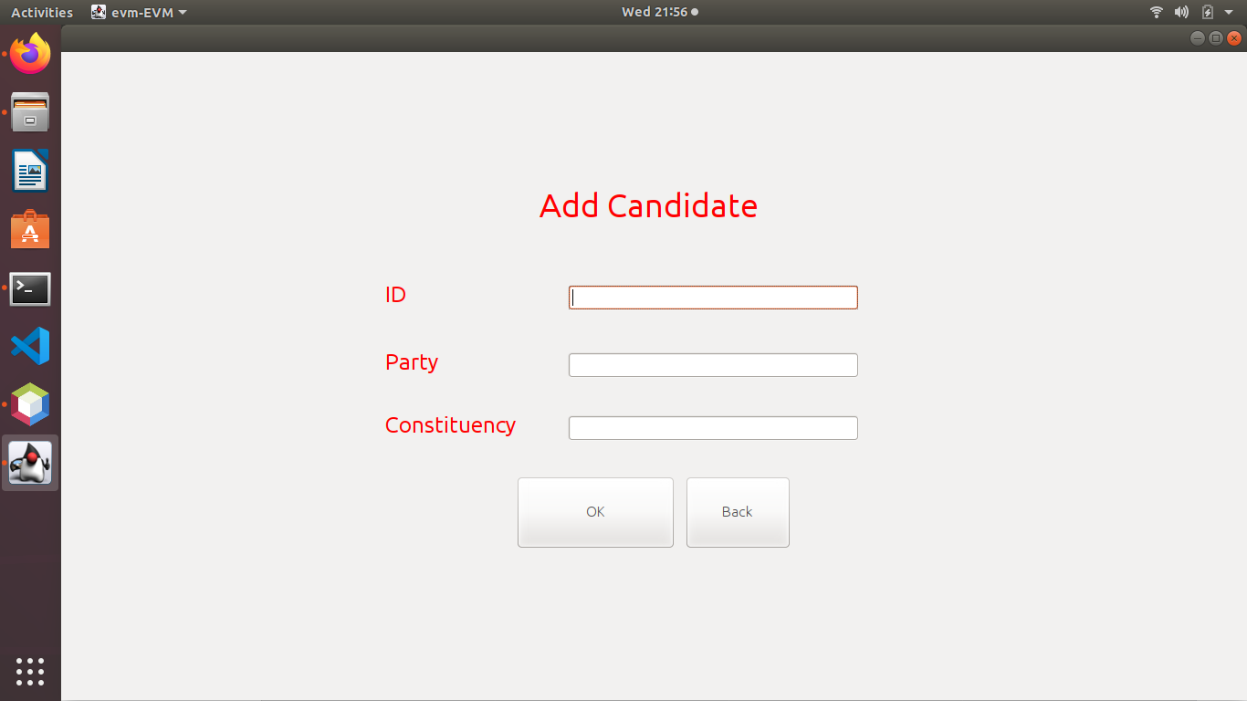

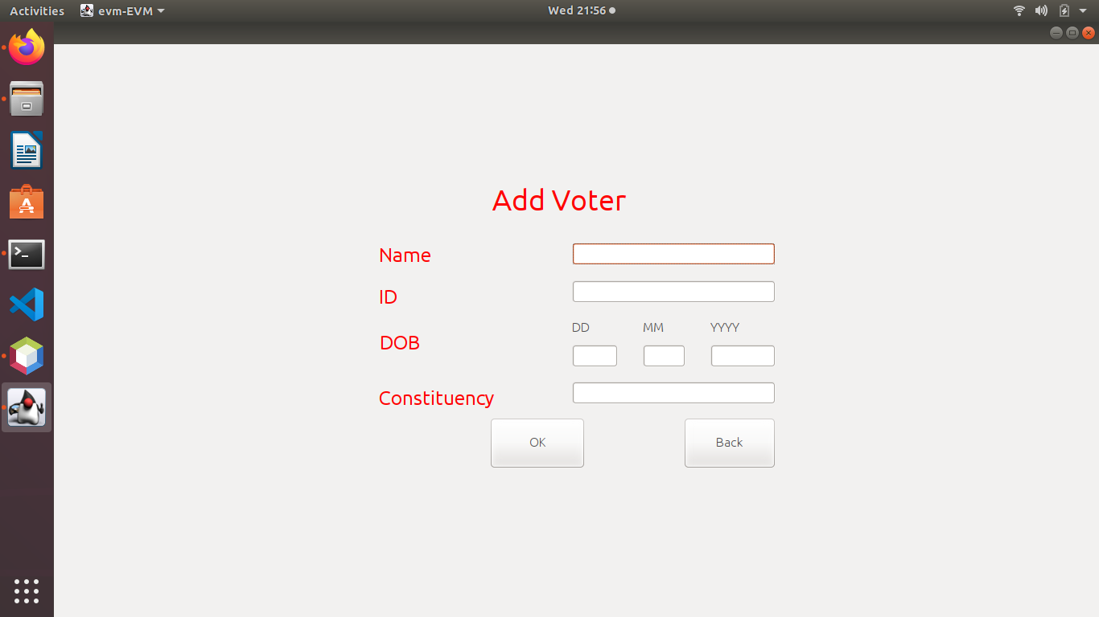

# 

**Polling phase**

The polling phase constitutes the list of valid voters who cast their votes. Moreover, the details of polling are allowed to be encrypted and data is shuffled using some random algorithms in order to prevent exposing the details of polling and voters’ privacy. The system ensures one voter- one vote scheme. Another major feature is that the portal is common for all constituencies and with voter id entered, the corresponding constituency can be identified.

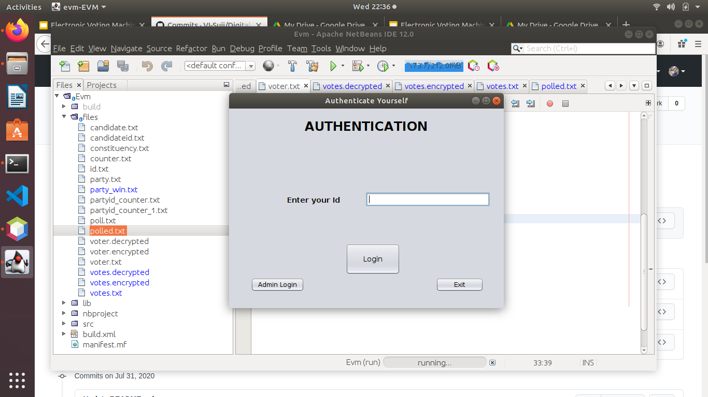

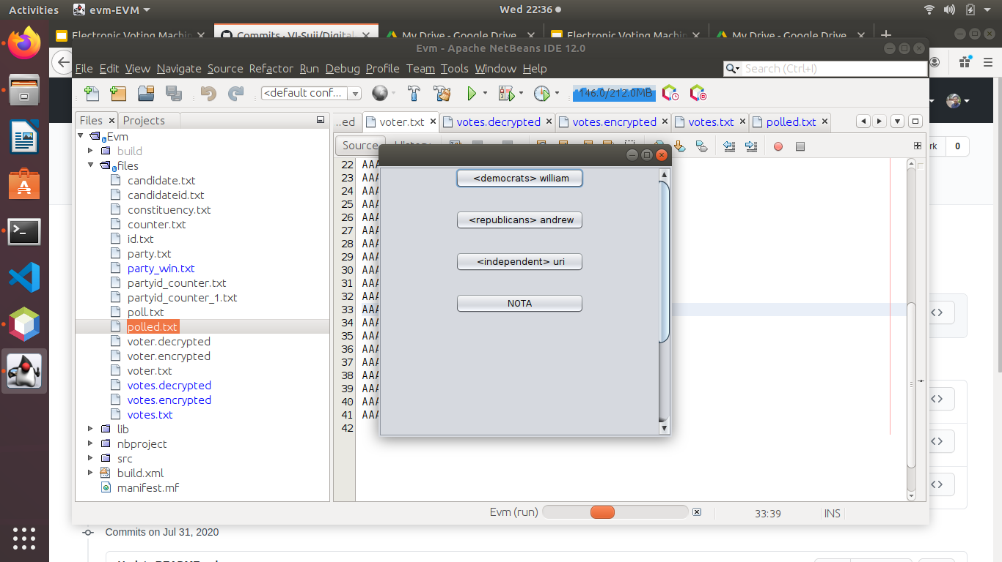

**Result phase**

The polling details without revealing the voter details are decrypted for result calculation. An overall election statistics (graphically) is provided in this phase with pie charts. The system declares the winner of each constituency as well as overall winner on the basis of the number of votes acquired by each candidate as well as no of seats acquired by the party.

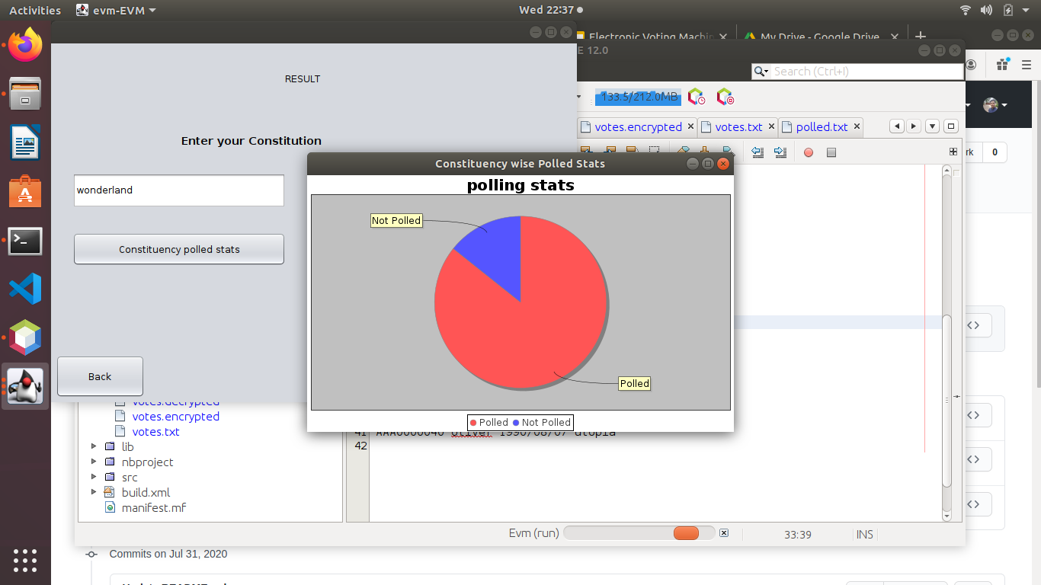

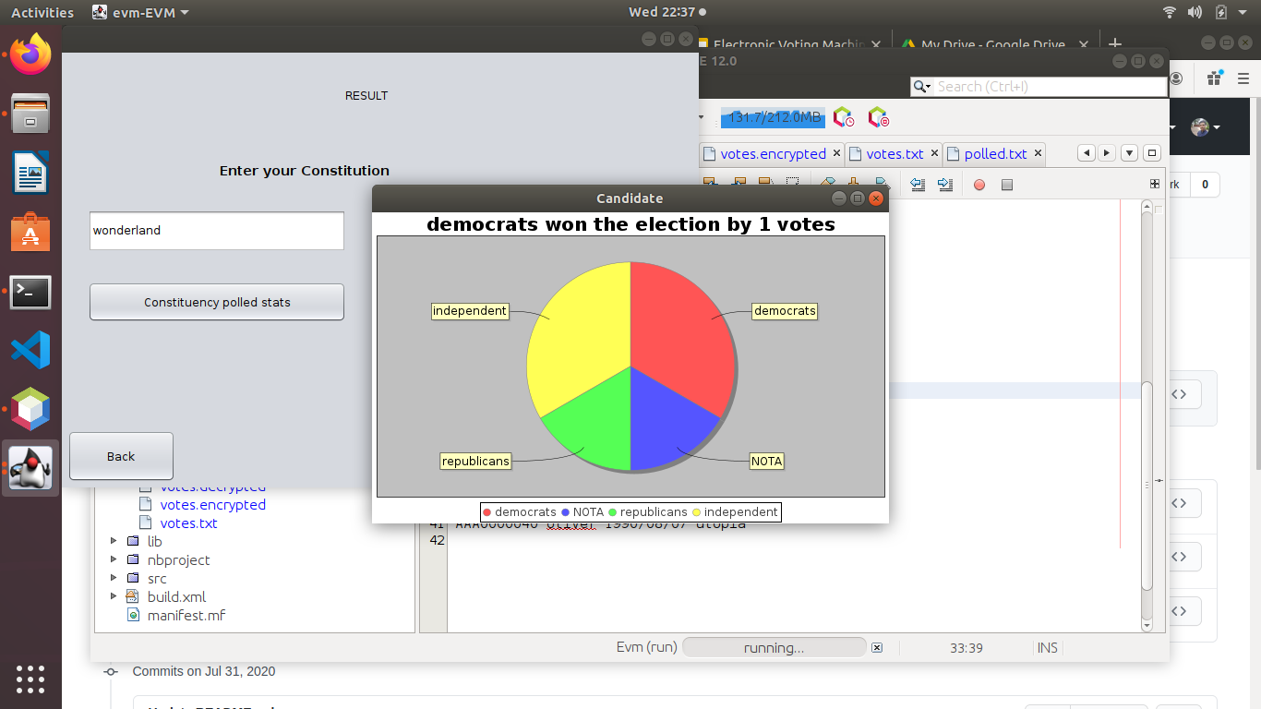

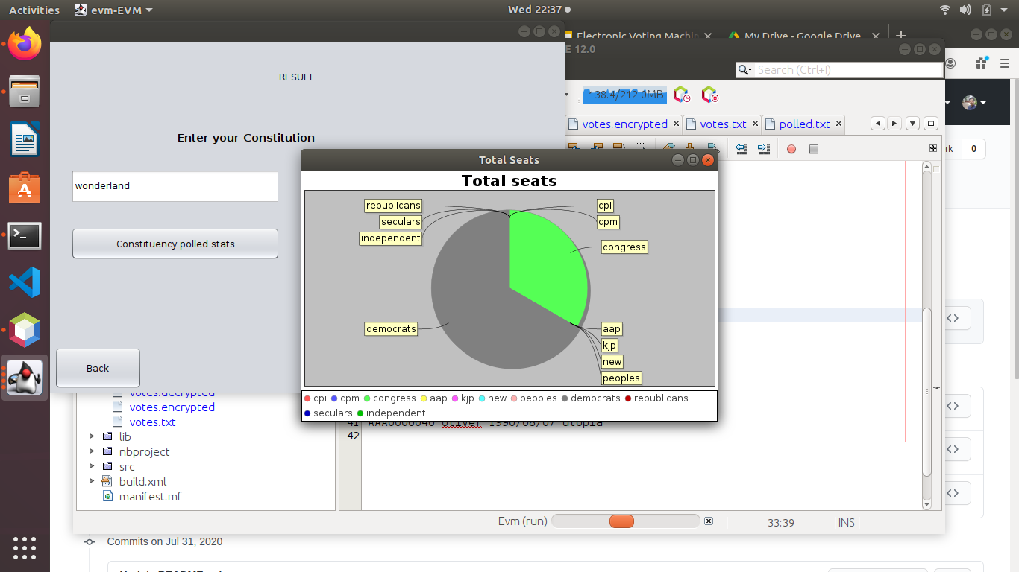

Conclusion

Digital voting machine is a powerful database based application software capable of handling all election procedures. It can handle pre election phase like voter, candidate, party, addition, modification and removal and on-election process including casting of votes, encrypting and storing the encrypted data to database etc also post election process consisting of decryption and fetching from db, result announcement and result generation including pie graphs of constituency wise, party wise and overall statistics. Moreover the encryption gives wider options for any high security election which are in large scale as well as small scale without the usage of any external softwares.

References

1. Fundamentals of Database Systems, 7th edition, Elmasri Ramez and Shamkant Navathe
2. Java, The complete reference,Eleventh Edition,Herbert Schildt
3. Electronic Voting Machine -A review, D.Ashok Kumar T. Ummal Sariba Begum , IEEE , Accessed on : 27th July, 2020 Available: https://ieeexplore.ieee.org/document/6208285

# 

# 

# 

# 

# 

# 

# 

# 